# Zonal level 2023-24

* BASEBALL under-14 (Girls)
* SECOND POSITION

|  |  |  |
| --- | --- | --- |
| S.NO. | NAME | CLASS |
|  | NITYA | VIII |
|  | PRIYAM | VIII |
|  | RIDDHIMA | VIII |
|  | VABHAVI | VIII |
|  | AASTHA | VIII |
|  | SIDDHI | VII |
|  | DIKSHA | VII |
|  | DEEPSHIKHA | VII |
|  | NAVYA | VII |
|  | NAVIKA | VI |
|  | AASMA | VI |
|  | KUNJAN | VI |
|  | SRISHTI | VI |
|  | SHREYA | VI |
|  | ARADHYA | VI |
|  | AASHI KUMARI | V |

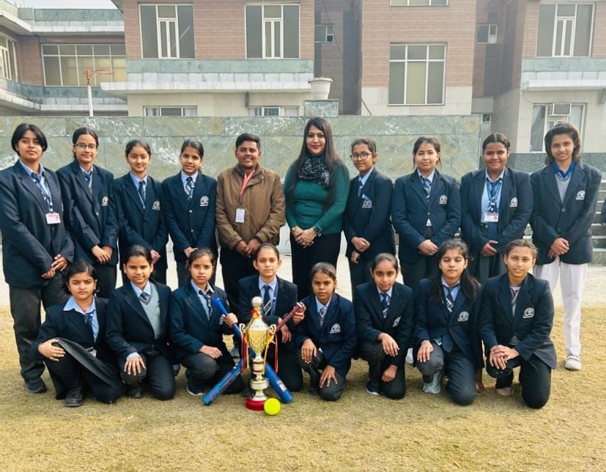

# Zonal level SOFTBALL COMPETITION 2023-24

* under-14 (Girls) FIRST Position

|  |  |  |
| --- | --- | --- |
| S.NO. | NAME | CLASS |
|  | NITYA | VIII |
|  | PRIYAM | VIII |
|  | RIDDHIMA | VIII |
|  | VABHAVI | VIII |
|  | AASTHA | VIII |
|  | SIDDHI | VII |
|  | DIKSHA | VII |
|  | DEEPSHIKHA | VII |
|  | NAVYA | VII |
|  | NAVIKA | VI |
|  | AASMA | VI |
|  | KUNJAN | VI |
|  | SRISHTI | VI |
|  | SHREYA | VI |
|  | ARADHYA | VI |
|  | AASHI KUMARI | V |



# Zonal level CHESS Competition

* CHESS (UNDER-17) FIRST PLACE

|  |  |  |
| --- | --- | --- |
| S.NO. | NAME | CLASS |
| 1 | ANSH | XI |

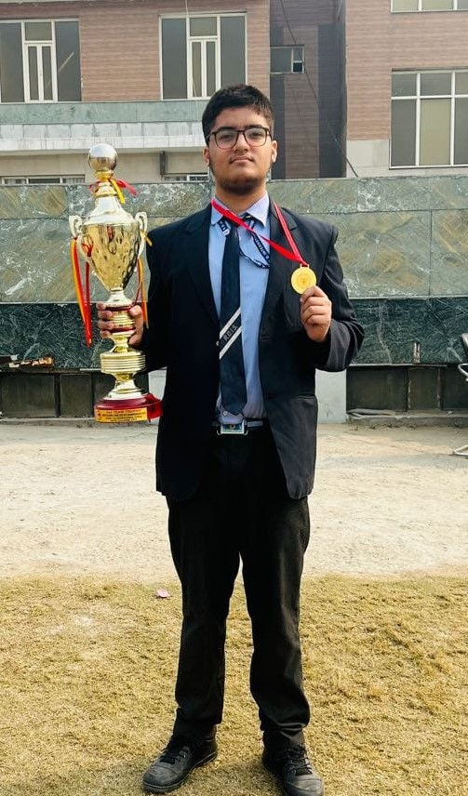

# Zonal level WRESTLING Competition 2023

* Under-19
* **First position**

|  |  |  |
| --- | --- | --- |
| S.NO. | NAME | CLASS |
| 1. | JAI | XI |

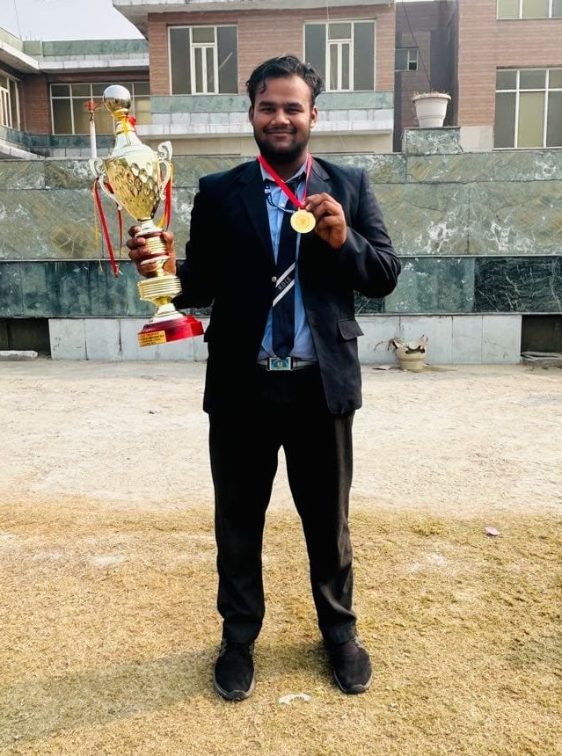

# Zonal level SWIMMING Competition 2023

* Under-14

400 MTR.:- FIRST position

200 MTR.:- SECOND Position

100 MTR.:- THIRD position

|  |  |  |
| --- | --- | --- |
| S.NO. | NAME | CLASS |
| 1. | ALOK | VI |

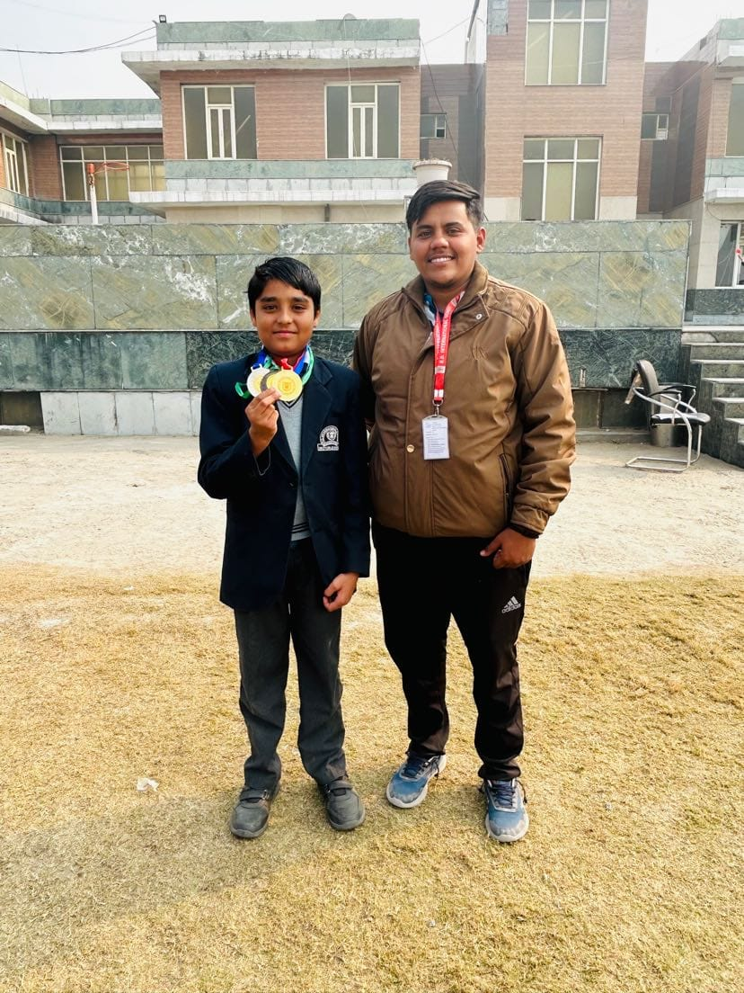

# Zonal level PRIMERY ATHLETICS meet 2023

* First position

|  |  |  |
| --- | --- | --- |
| S.NO. | NAME | CLASS |
| 1. | ZESHANUL | V |
| 2. | AASHI KUMARI | V |
| 3. | PIYUSH | III |

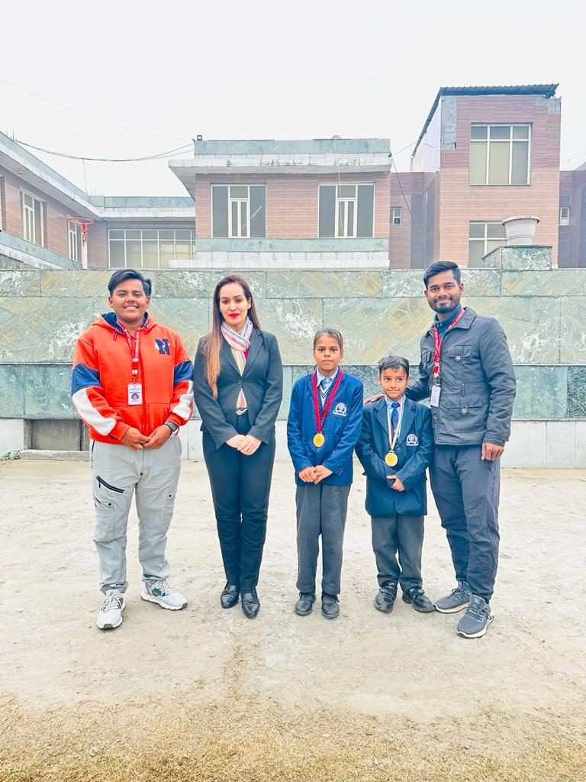

# Zonal level ATHLETICS meet 2023

* **RELAY RACE 4*100 MTR.**

**UNDER-14 (GIRLS)**

**FIRST POSITION**

|  |  |  |
| --- | --- | --- |
| **S.NO.** | **NAME** | **CLASS** |
| **1.** | **DIKSHA** | **VII** |
| **2.** | **SIDDHI** | **VII** |
| **3.** | **RIDDHIMA** | **VIII** |
| **4.** | **PRIYAM** | **VIII** |

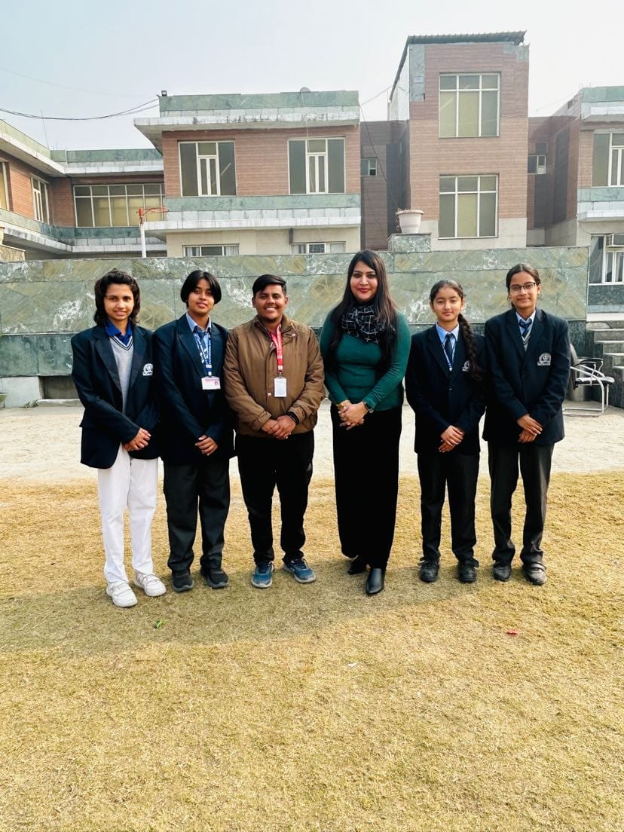

# Zonal level SKATING Competition 2023

* 500 MTR. & 1000 MTR. (Quads) (under-14)

First & second position

|  |  |  |
| --- | --- | --- |
| S.NO. | NAME | CLASS |
| 1. | ALOK CHHIKRA | VI |



# Zonal level SKATING Competition 2023

* 500 MTR. & 1000 MTR. (QUARD)

(Under-19 )

First position

|  |  |  |
| --- | --- | --- |
| S.NO. | NAME | CLASS |
|  | RAJEET | VI |

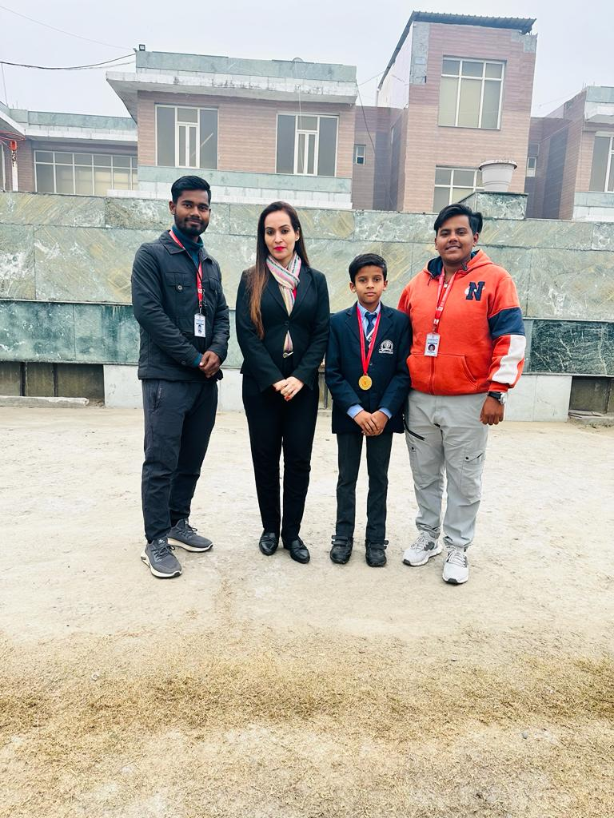

# Zonal level SKATING Competition 2023

* 500 MTR. (INLINE) First position
* 1000 MTR. (INLINE) Second position

|  |  |  |
| --- | --- | --- |
| S.NO. | NAME | CLASS |
| 1. | JIVESH | XII |

# Zonal level ATHLETICS meet 2023

* 600 MTR. & 400 MTR. Race (under-14)

Second position

* 600 MTR. ( under-14)

Third position

|  |  |  |
| --- | --- | --- |
| S.NO. | NAME | CLASS |
| 1. | DIKSHA | VII |
| 2. | SIDDHI | VII |

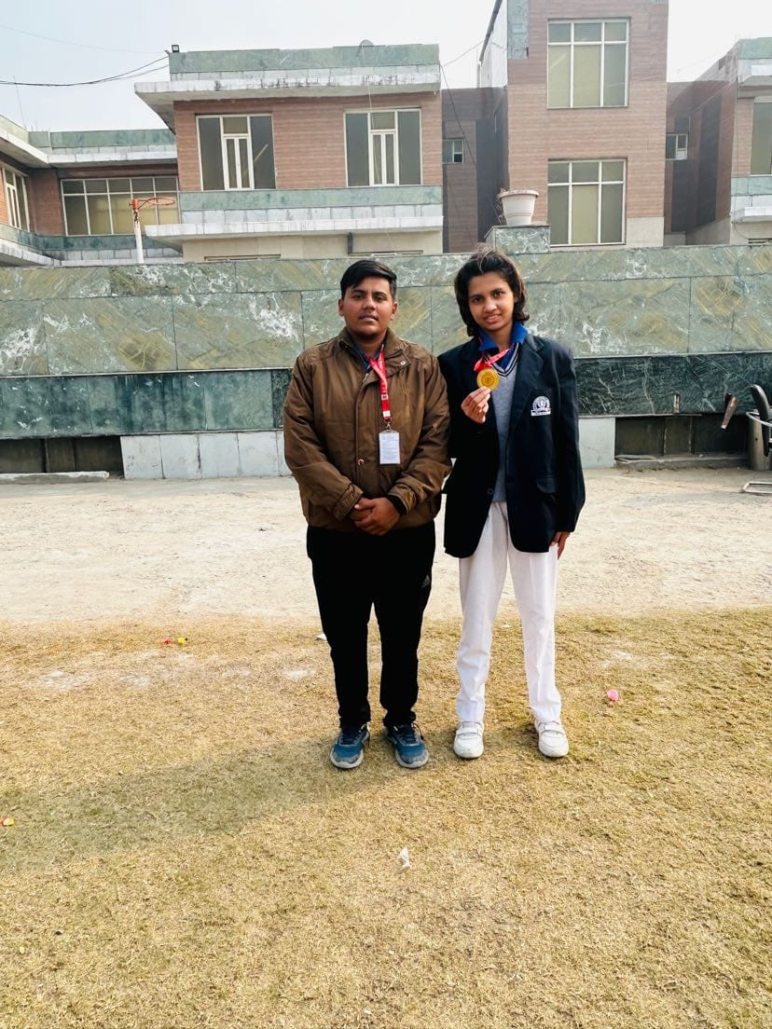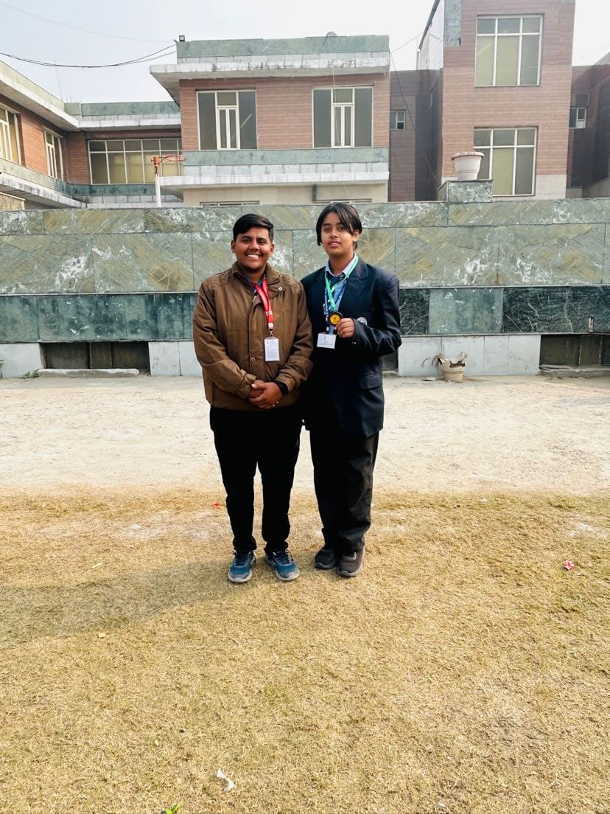

DIKSHA SIDDHI

( 400 MTR. & 600 MTR. RACE ) ( 600 MTR. RACE )

Unde-14 Under-14

# Zonal level TAEKWANDO Championship 2023

* -35 weight category (under-14)
* Second position

|  |  |  |
| --- | --- | --- |
| S.NO. | NAME | CLASS |
| 1. | VANSH | VII |

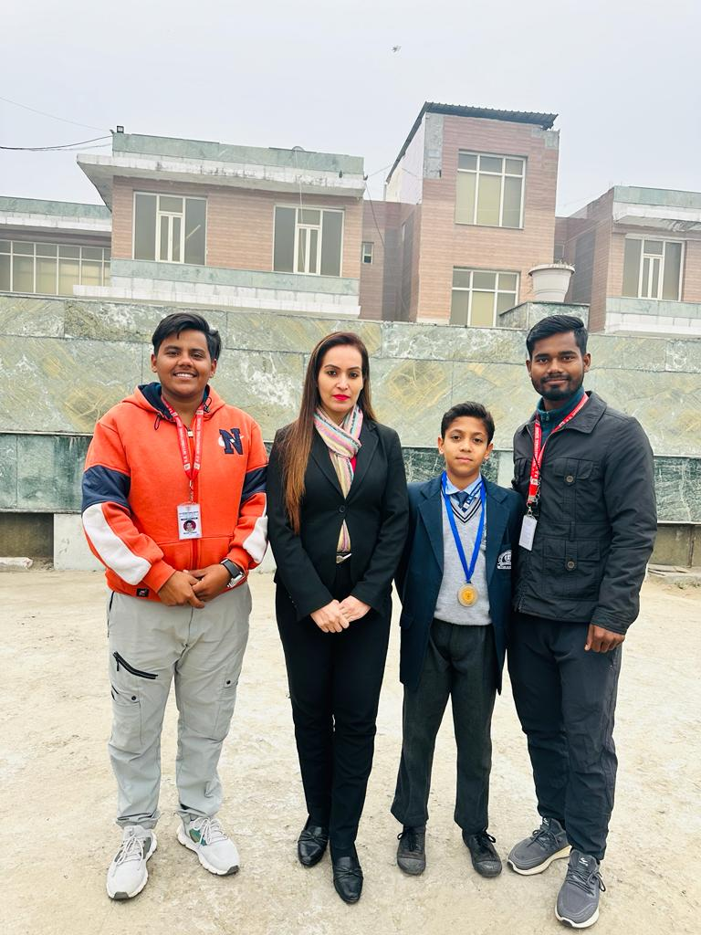

# Zonal level SWIMMING Competition 2023

* 100 MTR. , 200 MTR. & 400 MTR. (Free style) under-14
* First, second & third position

|  |  |  |
| --- | --- | --- |
| S.NO. | NAME | CLASS |
| 1. | ALOK CHHIKARA | VI |



# Zonal level Primary ATHLETICS meet 2023

* Primary athletics meet

Second position

|  |  |  |
| --- | --- | --- |
| S.NO. | NAME | CLASS |
| 1. | LAVYANSH | I |
| 2. | SIDDHIKSHA | II |
| 3. | ARYAN | V |

# Zonal level SKATING Competition 2023

* 100 MTR., 500 MTR. & 1000 MTR. (INLINE) (Under-11)

Second & Third place

* 200 MTR. (QUARD) (Under-14)

Second position

|  |  |  |
| --- | --- | --- |
| S.NO. | NAME | CLASS |
| 1. | AKSHAT | IV |
| 2. | EKASVEER | V |
| 3. | ALOK CHHIKARA | VI |

# Zonal level SKATING Competition 2023

* 500 MTR. & 100 MTR. (INLINE) (Under-19)

First & second position

|  |  |  |
| --- | --- | --- |
| S.NO. | NAME | CLASS |
| 1. | JIVESH | XII |

# Zonal level SOFTBALL Championship 2023

* Under-17 (boys) second position

|  |  |  |
| --- | --- | --- |
| S.NO. | NAME | CLASS |
| 1. | GULSHAN | X |
| 2. | AYAN | X |
| 3. | PUKHRAJ | XII |
| 4. | SANCHIT | IX |
| 5. | PURAV | IX |
| 6. | MOHIT | IX |
| 7. | KANISHK | X |
| 8. | HARSHIT | X |
| 9. | DHRUV | IX |
| 10. | MAYANK | IX |
| 11. | RUDRAKSH | XI |
| 12. | MANISH | XI |
| 13. | KANISHK | XII |

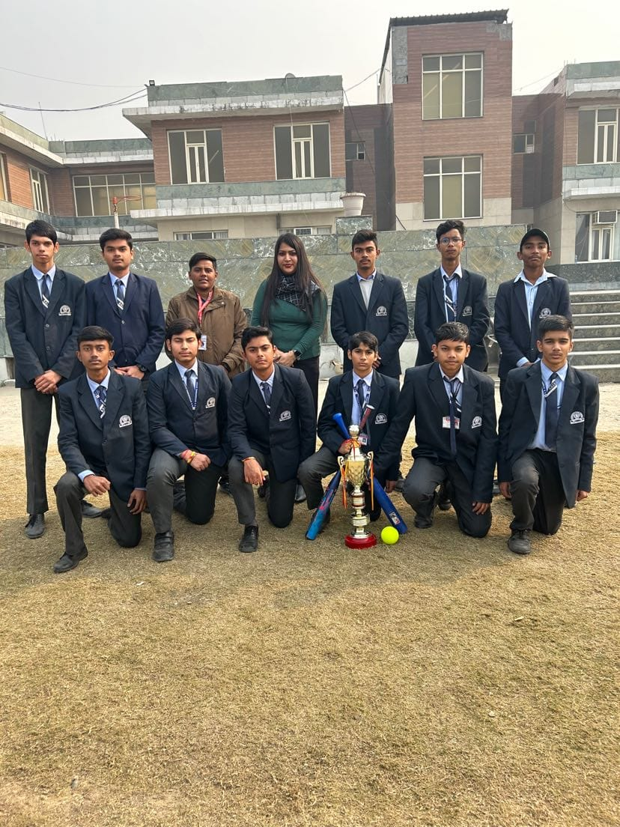

# Zonal level BASEBALL Competition 2023

* Under-14 (boys) second place

|  |  |  |
| --- | --- | --- |
| **S.NO** | **NAME** | **CLASS** |
| **1** | **HIMANSHU** | **Vll** |
| **2** | **HARSH** | **Vll** |
| **3** | **VANSH** | **Vll** |
| **4** | **BHAVESH** | **Vll** |
| **5** | **GAVIST** | **Vll** |
| **6** | **SHLOK** | **IX** |
| **7** | **UDAY** | **Vlll** |
| **8** | **RAKSHIT** | **Vl** |
| **9** | **RAJEET** | **Vl** |
| **10** | **HIMANSHU** | **V** |
| **11** | **ZEESHANUL** | **V** |
| **12** | **ARSHAD** | **Vll** |
| **13** | **ARYAN** | **V** |
| **14** | **FARHAN** | **VI** |
| **15** | **PARTH** | **VI** |
| **16** | **DAKSH** | **VIII** |

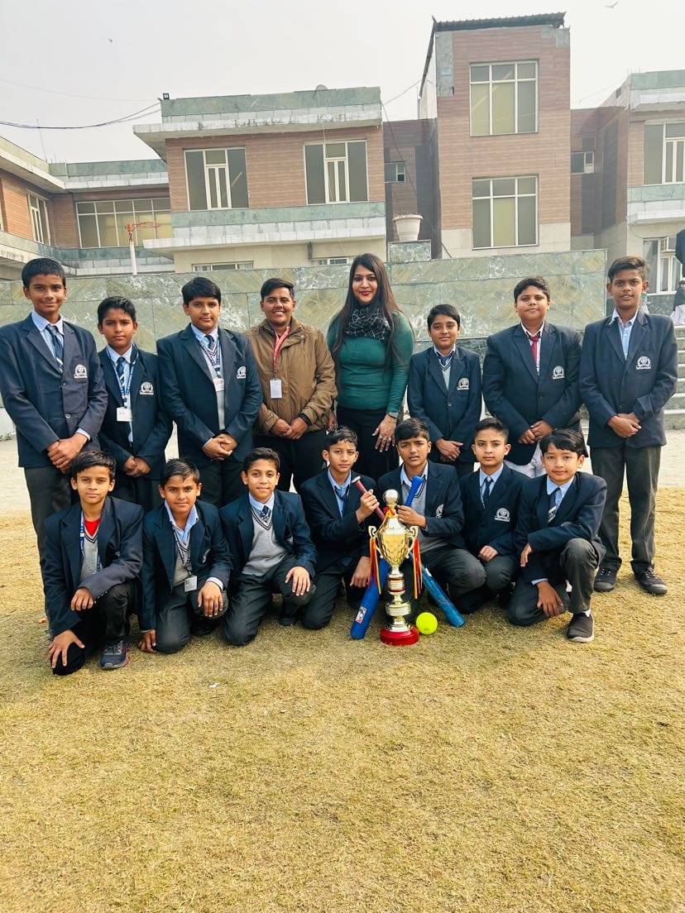

# Zonal level SOFTBALL Competition 2023

* Under-14(Boys) THIRD position

|  |  |  |
| --- | --- | --- |
| **S.NO** | **NAME** | **CLASS** |
| **1** | **HIMANSHU** | **Vll** |
| **2** | **HARSH** | **Vll** |
| **3** | **VANSH** | **Vll** |
| **4** | **BHAVESH** | **Vll** |
| **5** | **GAVIST** | **Vll** |
| **6** | **SHLOK** | **IX** |
| **7** | **UDAY** | **Vlll** |
| **8** | **RAKSHIT** | **Vl** |
| **9** | **RAJEET** | **Vl** |
| **10** | **HIMANSHU** | **V** |
| **11** | **ZEESHANUL** | **V** |
| **12** | **ARSHAD** | **Vll** |
| **13** | **ARYAN** | **V** |
| **14** | **FARHAN** | **VI** |
| **15** | **PARTH** | **VI** |
| **16** | **DAKSH** | **VIII** |



# Zonal level FOOTBALL Competition 2023

* Under-17 (boys) Second position

|  |  |  |
| --- | --- | --- |
| **S.NO.** | **NAME** | **CLASS** |
| **1** | **UDAY** | **VIII** |
| **2** | **MOHIT** | **VIII** |
| **3** | **DAKSH** | **VIII** |
| **4** | **NIPUN** | **VIII** |
| **5** | **KHUSHAL** | **VIII** |
| **6** | **AARUSH** | **VIII** |
| **7** | **ARYAN** | **VIII** |
| **8** | **ARSH** | **VIII** |
| **9** | **RITESH** | **VIII** |
| **10** | **SHLOK** | **IX** |
| **11** | **HARSHIT** | **X** |
| **12** | **ZEESHANUL** | **V** |

